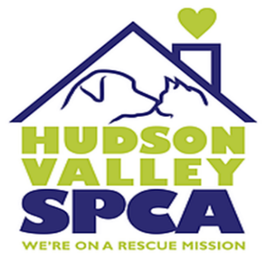
Volunteer & Community Service Application

940 Little Britain Road New Windsor, NY 12553 845-564-6810
www.HudsonValleySPCA.org

Name: ___________________________________________ Date:______________________

Address:_________________________________________City:_____________________________ Zip:_____________
Phone:_____________________________ E-mail:_________________________________________

Are you allergic to any animals? (circle one) YES NO DOGS or CATS (circle one)

Are you a minor/under 18 (circle one): YES NO If a minor, how old are you?__________________
If you are a minor, parental consent is required. Please provide parent/guardian name and phone: Parent/Guardian Name(s):_____________________________________________________________ Phone:_______________________________ Alternate Phone:________________________________

Please check the areas in which you would like to help:
Dogs____ Cats____Gardening____Yardwork____ Fundraising_____Events/Promotions____

Is this for Community Service for a school, religious organization. etc. (circle one) YES NO If YES:

How many hours are needed____________ Organization:____________________________
Contact person:________________________ Phone #:_________________________________

Is this Court mandates (circle one) YES NO Offense:__________________________________
Court:_______________________________ Hours Needed:____________________________

In case of an emergency (or if parent/guardian cannot be reached) provide an emergency contact:

Name:______________________________Phone:_________________Relationship:______________

Volunteer Disclaimer

I, _________________________________understand that
I will be supervised b an HVSPCA employee while volunteering (volunteering includes but is not limited to assisting and attending to dogs or cats housed at the HVSPCA).

If I am over the age of 18, duties will include (but not be limited to) cleaning cages/outside runs, cleaning reception areas, gardening/yard work, walking and watering dogs, feeding and watering cats and fundraising.

If I am under the age of 18 my duties will include (but not be limited to) cleaning cages, cleaning outside runs, yard work, reception area cleaning, helping in the cat rooms and fundraising.

I understand that some animals have unknown backgrounds and may behave unpredictably at times due to the neglect and/or abuse they may have suffered. I will follow ALL shelter guidelines provided by HVSPCA staff when interacting with the animals. I understand that all animals housed at the HVSPCA are legally immunized by a veterinarian. I understand that if at any time animas become involved in an altercation, I will NOT intercede but will call a staff member IMMEDIATELY. I also will not hold the HVSPCA liable should I be injured while volunteering.

Volunteer Signature:__________________________________________________
Volunteer Printed Name:______________________________________________

Parent/Guardian Signature______________________________________________
Parent/Guardian Printed Name:__________________________________________
Date:__________________________________________________

